Date:

Lab Session No.: 10

**Aim:**

Develop an android application to implement user interface by using User Interface (UI) or input controls available in android. DatePicker, TimePicker

**Software’s /IDE Tools:**

Android Development Kit / Android Studio

**Application User interface design:**

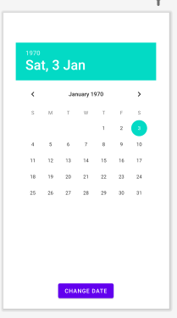

**Application Programming Interface:**

|  |  |  |  |
| --- | --- | --- | --- |
| **API / PACKAGES** | **CLASSES / INTERFACES** | **METHODS** | **DESCRIPTION** |
| import androidx.appcompat.app.AppCompatActivity; | AppCompatActivity | protected void onCreate(Bundle savedInstanceState) | onCreate(Bundle) is where you initialize your activity. When Activity is started and application is not loaded, then both onCreate() methods will be called. |
|  |  |
| import android.widget.EditText; | EditText | getText() | Determines the minimum type that getText() will return. If set, specifies that this TextView has a textual input method and should automatically capitalize what the user types. |

**Code/Implementation:**

// Develop an android application to implement user interface by using User //Interface (UI) or input controls available in android. DatePicker, TimePicker

/*

Lab Session No. : 10

Author : Tellakula Avinash

Date :

Roll Number : 198W1A05C0

Description : Implementation of DatePicker, TimePicker

Softwares required :

Android Studio

Topics Covered :

DatePicker, TimePicker

*/

*MainAcitivity.java*

**import** android.support.v7.app.AppCompatActivity;

**import** android.os.Bundle;

**import** android.view.View;

**import** android.widget.Button;

**import** android.widget.DatePicker;

**import** android.widget.TextView;

**public** **class** MainActivity **extends** AppCompatActivity {

    DatePicker picker;

    Button displayDate;

    TextView textview1;

    @Override

**protected** **void** onCreate(Bundle savedInstanceState) {

**super**.onCreate(savedInstanceState);

        setContentView(R.layout.activity_main);

        textview1=(TextView)findViewById(R.id.textView1);

        picker=(DatePicker)findViewById(R.id.datePicker);

        displayDate=(Button)findViewById(R.id.button1);

        textview1.setText("Current Date: "+getCurrentDate());

        displayDate.setOnClickListener(**new** View.OnClickListener(){

            @Override

**public** **void** onClick(View view) {

                textview1.setText("Change Date: "+getCurrentDate());

            }

        });

    }

**public** String getCurrentDate(){

        StringBuilder builder=**new** StringBuilder();;

        builder.append((picker.getMonth() + 1)+"/");//month is 0 based

        builder.append(picker.getDayOfMonth()+"/");

        builder.append(picker.getYear());

**return** builder.toString();

    }

}

*activity_main.xml*

*<?*xml version="1.0" encoding="utf-8"*?>*<RelativeLayout xmlns:android="http://schemas.android.com/apk/res/android"  
 xmlns:app="http://schemas.android.com/apk/res-auto"  
 xmlns:tools="http://schemas.android.com/tools"  
 android:layout_width="match_parent"  
 android:layout_height="match_parent">  
  
 <TextView  
 android:id="@+id/textView1"  
 android:layout_width="wrap_content"  
 android:layout_height="wrap_content"  
 android:layout_above="@+id/button1"  
 android:layout_alignParentLeft="true"  
 android:layout_alignParentStart="true"  
 android:layout_marginBottom="102dp"  
 android:layout_marginLeft="30dp"  
 android:layout_marginStart="30dp"  
 android:text="" />  
  
 <Button  
 android:id="@+id/button1"  
 android:layout_width="wrap_content"  
 android:layout_height="wrap_content"  
 android:layout_alignParentBottom="true"  
 android:layout_centerHorizontal="true"  
 android:layout_marginBottom="20dp"  
 android:text="Change Date" />  
  
 <DatePicker  
 android:id="@+id/datePicker"  
 android:layout_width="wrap_content"  
 android:layout_height="wrap_content"  
 android:layout_above="@+id/textView1"  
 android:layout_centerHorizontal="true"  
 android:layout_marginBottom="36dp" />  
  
</RelativeLayout>

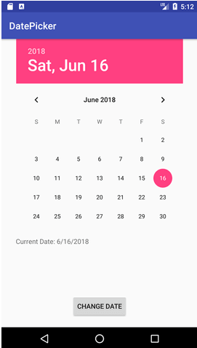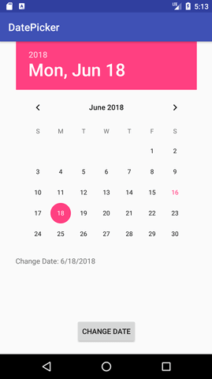**Output:**

**Result:**

Demonstration the DatePicker were done successfully.